📊 GBPJPY (H1) — Decision
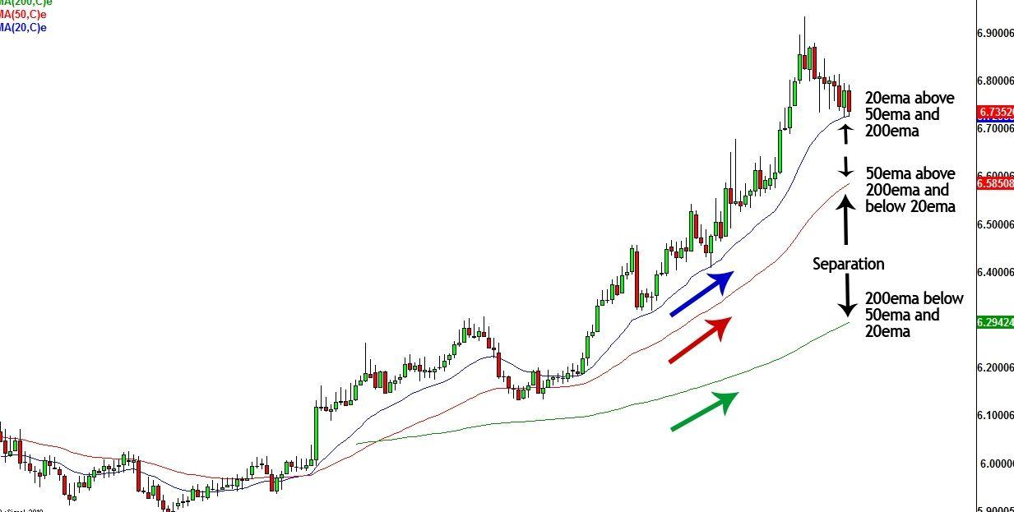
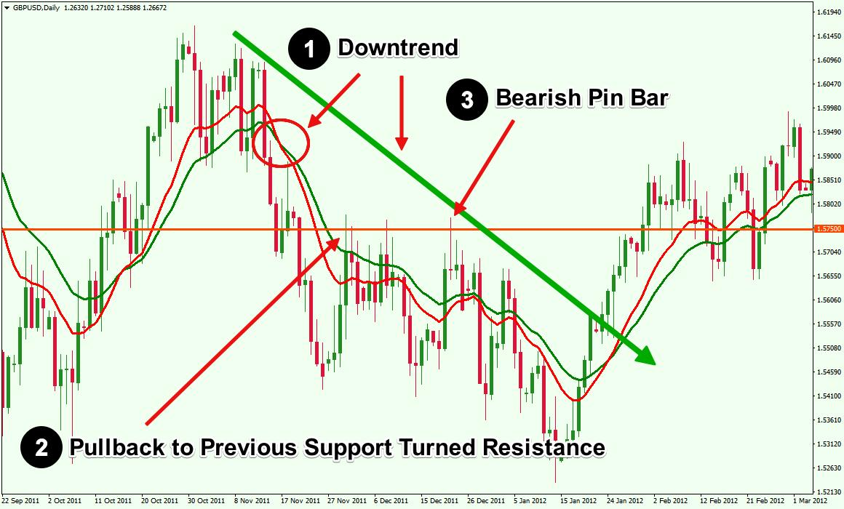
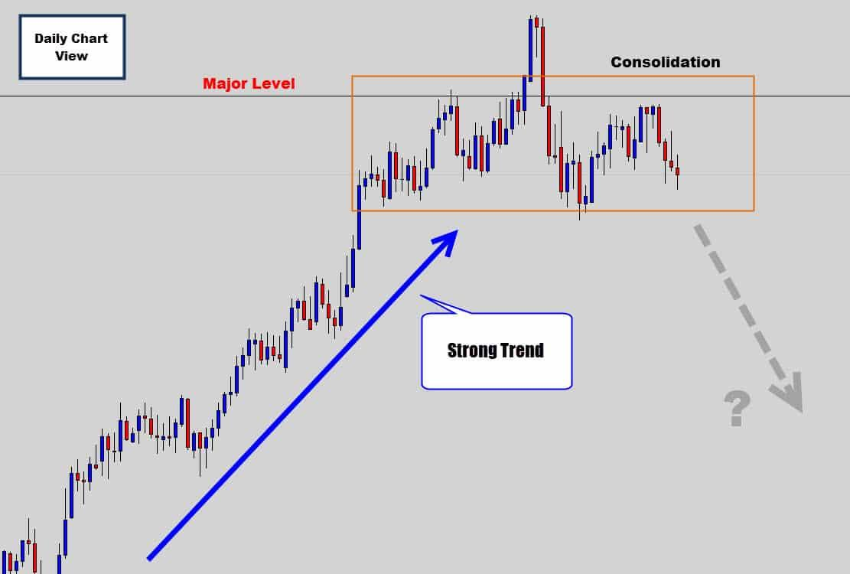
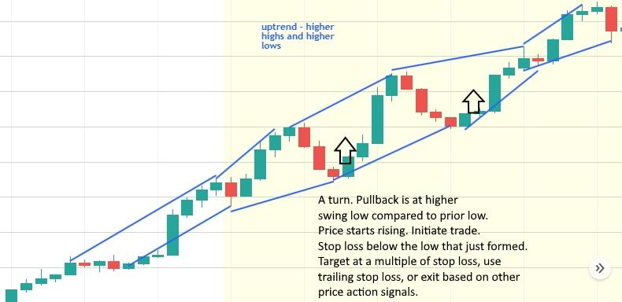
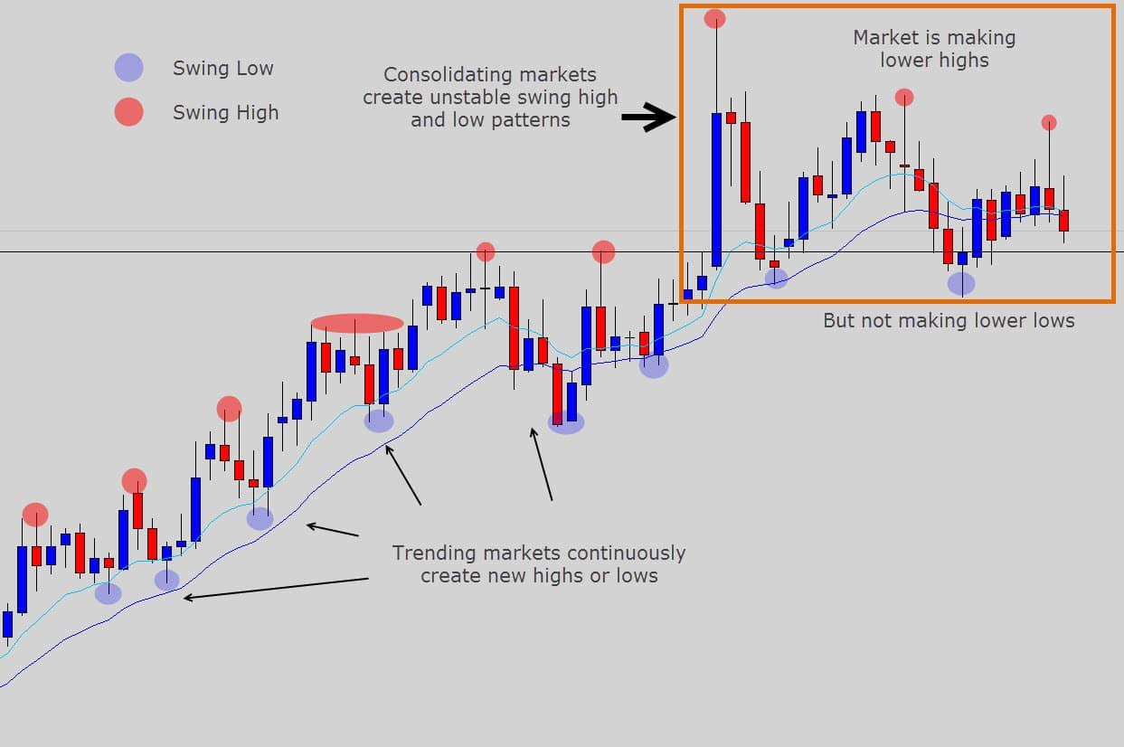
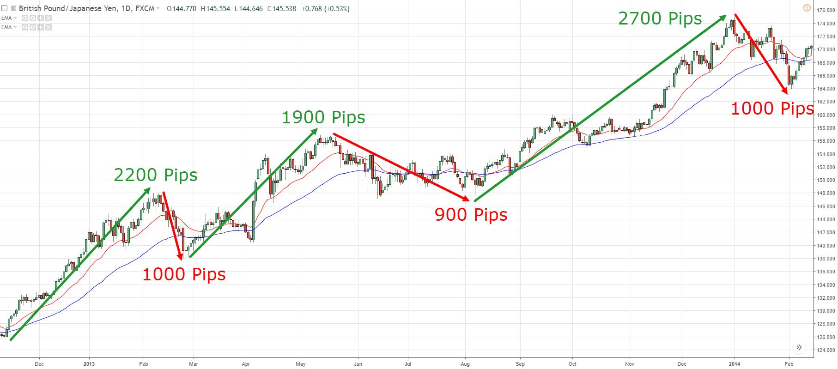

🔍 What I’m Seeing
- Strong uptrend structure (clear higher highs & higher lows)
- Price is well above EMA 200 (blue) → strong bullish bias
- EMA 50 (red) is sloping up → momentum intact
- Recent move shows continuation after consolidation
👉 This is a BUY market

⚠️ But Don’t Rush Entry
Right now:
- Price has already moved up strongly
- Slight pullback / pause happening
👉 That means:
- ❌ Don’t buy at the top
- ✅ Wait for a better entry

🎯 Best Trade Plan

🥇 Option 1: Pullback Entry (BEST)
Wait for:
- Price to retrace toward EMA 50
- Bullish confirmation (strong green candle)
👉 Then BUY

🥈 Option 2: Breakout Continuation
- If price breaks above recent high
- Enter on small pullback/retest
👉 Then BUY

❌ Avoid
- Buying after big spike candles
- Entering when price is far from EMA

🧠 EA Perspective
Your bot should:
- Prefer BUY trades only
- Use pullback + EMA confirmation for entries

🔥 Final Answer
👉 Direction: BUY
👉 Action: WAIT for pullback or breakout confirmation

If you want next:
I can now upgrade your EA with:
- Pullback detection
- Trade limiter (no overtrading)
- Stop Loss / Take Profit auto setup
Just say: “optimize entries” 🚀

